**Fredrick Onduso Ondieki**

**CST – 221**

**John Zupan**

**March 5, 2019**

**CST-221 Systems and Tools**

To carry out this assignment successfully, I chose to write the assignment in paragraph form instead of the tabular form as asked. This is because I wanted to give a better explanation of the points on the assignment of which it would be difficult to put in tabular form.

**Operating systems exploration- Features execution**

Opening a file- Saved word document

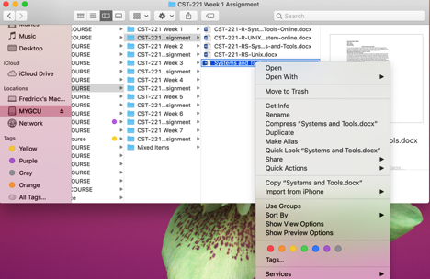To open a file, the user must select the file and then executes the command to open the selected or searched file. After executing the opening command, the command then passes instruction to the operating system Kernel to find the path or the location of the file. The Kernel gets the path as well as the file and stores as it passes to the right program that lunches the file. In other words, if the application program for example the MS Word software is not active, the Kernel will launch the software. Afterwards, the application complies all file data and successful compilation results to the application opening the file.

Saving a picture or file to directory

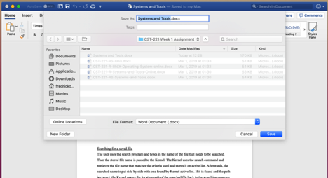To save a picture or any file to directory, the user executes the saving command. All the picture or file parts are moved from the application that was running the file to the Kernel. Kernel then prompts the user to the location where the file will be saved, and the user selects the directory to where he/she wants the file or picture saved. If the file exists on the directory, the Kernel will use its reference memory feature to overwrite the existing contents and thus save the new file objects. If successful, the application that was used will let the user know if the file was saved successfully or not.

Searching for a saved file

The user uses the search program and types in the name of the file that needs to be searched. Then the stored file name is passed to the Kernel. The Kernel uses the search command and retrieves the file name that matches the criteria used and stores it on active list. Afterwards, the searched name is put side by side with one found by Kernel active list. If it is found and the path is correct, the Kernel passes the location path of the searched file back to the searching program and thus displays the searched file.

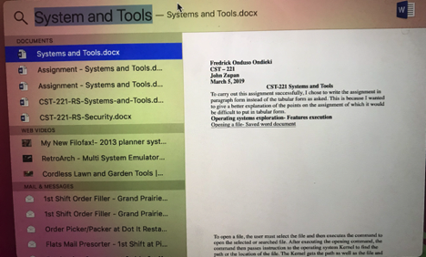

Display a picture on desktop

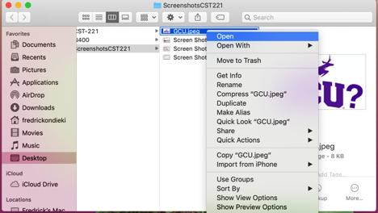The program that is used to display the picture on the desktop is loaded. It sets up the stage and scene according to the image properties to be displayed. The application then checks its location and the image is added to the scene. Upon execution of the kernel display “something” command, the kernel passes the results to the application and the already set stage is updated with a current image scene.

Launching an MS Word Application

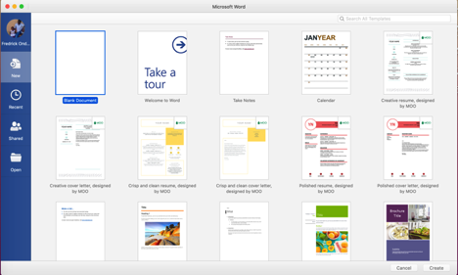The MS Word application is selected and clicked to be opened. The application launcher gets the command and communicates with kernel and all the necessary files are retrieved from the memory. After the files have been retrieved, the file objects are then passed back to the MS Word application and the application launcher compiles all the files and runs/opens the application.

**Proof of Unix/Linux on Operating system and Screen shots**

As a requirement for this course, we need to prove the readiness to run the C programs in a Linux or Unix environment. Since I am using a Mac Pc, I have UNIX system running. However, if I were to use a windows system, I would therefore install a Linux distribution system.

The following screenshots illustrate or rather provides proof of the system.

Terminal Screenshot

On this course, to run my Hello World classic program, I used Xcode development tool as shown on the screenshot bellow.

References

Estes, P. (2018, May 21). Linux vs. Unix: What's the difference? Retrieved March 7, 2019, from https://opensource.com/article/18/5/differences-between-linux-and-unix

Hoffman, C. (2016, September 22). Retrieved from https://www.howtogeek.com/182649/htg-explains-what-is-unix/

Indiana University. Introduction to Unix commands. (2019, February 28). Retrieved March 7, 2019, from https://kb.iu.edu/d/afsk

Unix / Linux - Getting Started. (n.d.). Retrieved March 7, 2019, from https://www.tutorialspoint.com/unix/unix-getting-started.htm